Physical Science and engineering Department
Wilbur Wright College- Spring 2022

Lab 3 – Resistors Series - Parallel

Objectives
In this lab we will become familiar with some meters, resistors, and how to use the breadboard. Measure Voltage Drops across resistors in series and parallel. Getting familiar with identifying resistor’s values.

Equipment used in this lab
- Handheld Digital Multimeter (DMM)
- Breadboard
- Assorted resistors (270 , 330 and 510 )
- Power Supply
- Wires and alligators

Theory About Meters and Breadboards

An ammeter is a device used to measure the current, that is the flow of electric charge in a conductor. The SI unit of current is the Ampere (or Amp): 1 Ampere = 1A = 1 coulomb per second. The flow of current is determined by the resistivity of the conductor, and a device that assigns a specific resistance in a circuit is called a resistor (R).

A voltmeter is an instrument specifically designed to measure the electric potential difference between
two points in a circuit. This electric potential difference, commonly denoted V , is also referred to as
voltage with the SI unit of volt (V). For now, you can think of the voltage as the difference in electric
potential energy (PE) of a test charge moving between two points. The voltmeter measures the voltage
between two points in a circuit/system, such as across a resistor or a battery.

A multimeter is an instrument that combines the ammeter and the voltmeter to measure various functions such as voltage, current, and resistance. In this lab we will use a digital multimeter (DMM) as our voltmeter.

Resistors: The typical resistor used here is a carbon resistor that is usually marked with colored bands to indicate its resistance in Ohms () (see Figure 1). Each color has a value associated with it. A table of the color code is given below. To be able to read the color code, first orient the resistor as shown in the figure so that it "reads" from left to right.

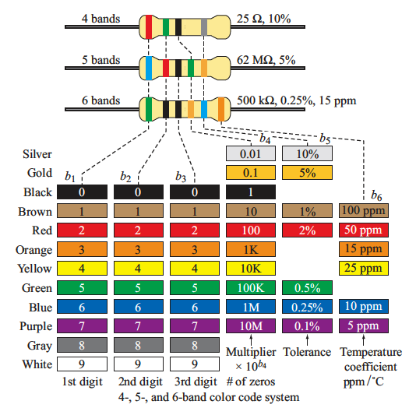

Breadboard: A breadboard circuit is usually a thin board where one can plug a circuit component like a resistor, capacitors, diodes to assemble circuits for experiments, practical application or to test the properties of the circuit. Typically, breadboard are used to make up temporary circuits. This means that no soldering is required. The components can be connected, changed, replaced and re-used afterwards. A typical breadboard is made up of two areas: Terminal Strips and Bus Strips. Terminal strips are the main areas of the breadboard and hold most of the electronic components of the circuit, such as Resistors, capacitors, etc, the terminal strip are denoted with a green line in the figure below, each line has five points, and they are all connected underneath. The terminal strips are separated by a notch (blue arrow). The Bus Strips provide power to the circuit components. They consist of two parallel columns (red and blue long lines in the figure)

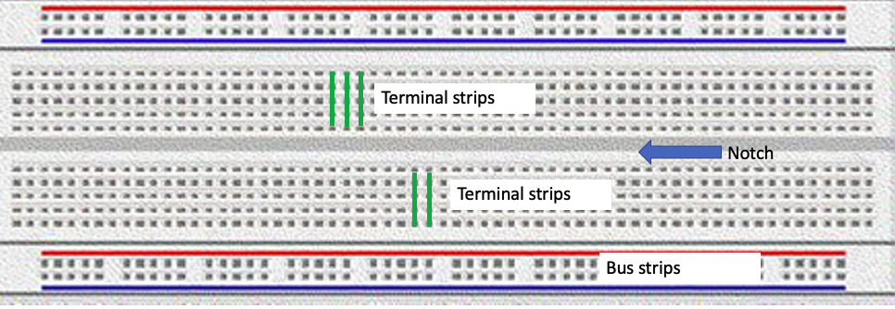

Experimental Procedure

- Measure the value of the resistors using the Digital Multimeter (DMM)

Take 6 resistors and fill the information in the following table: Identify the resistors from 1 to 6 and in column 1, second column put the colors of each band that you see in the resistors; third column will be for what we will call “nominal value” if the resistance using the colors; forth column is an actual measurement of the resistance using the DMM.

Resistor | Color strips | Nominal value of the resistance [ | Resistance measured with DMM [ | % Error
1 | Blue grey green silver | 6800 KOHM \pm 10\% | 7200 KOHM | 5.88
2 | Blue grey yellow silver | 680 KOHM\pm 10\% | 644 KOHM | 5.29
3 | Red purple orange silver | 27 KOHM\pm 10\% | 27.35 KOHM | 1.30
4 | Red red red silver | 2200 OHM\pm 10\% | 2198 OHM | 0.09
5 | Orange orange brown silver | 330 OHM\pm 10\% | 334.5 OHM | 1.36
6 | Yellow purple black gold | 47 OHM\pm 15\% | 47.5OHM | 1.06

Calculate the % error using the following expression, taking the nominal value as theoretical

Questions:
- Include here a picture of the set-up of just one measurements of resistance (showing the value in the display of the DMM)
- Do some research about the meaning of the tolerance (gold or silver colors). Are the resistors within specification? Explain.

- Series Circuit

- Build the circuit in the figure below. Leave the circuit open, meaning don’t close it until all the connections are checked and safe.
- You can start setting up the power supply to 4V.
- Measure the voltage drop around each resistor (column 2)
- Calculate the current (column 3).
Fill all the values in the table below

- Include a picture of your setup here
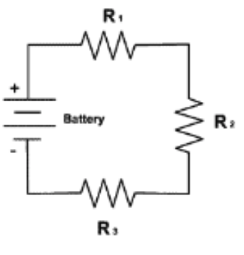

Resistor [ | Voltage Drop [V]  (Measured) | Current [A]  (Calculated I=V/R)
368.2 | 1.2 | 3.26 mA
328.7 \Omega | 1.07 | 3.26 mA
521.9 \Omega | 1.7 | 3.26 mA

Questions:
- Did you get the same value of current across all the resistors?
Yes sir!
- What is the equivalent resistance of the circuit?
1221.2
- Did the voltage drop across the resistors add up to the value of the power supply? What is the percent Error?
No, 0.75 percent error

- Parallel Circuit

- Build the circuit in the figure below. Leave the circuit open, meaning don’t close it until all the connections are checked and safe.
- You can start setting up the power supply to 4V.
- Measure the voltage drop around each resistor (column 2)
- Calculate the current (column 3).
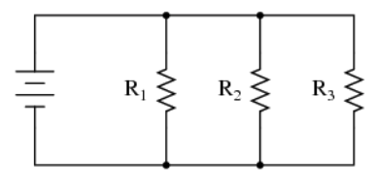
Resistor [ | Voltage Drop [V]  (Measured) | Current [A]  (Calculated I=V/R)
368.2 | 3.9 | 106 mA
328.7 | 3.9 | 119 mA
521.9 | 3.9 | 74.7 mA

- Include a picture of your set up here
- Calculate the power dissipated by each resistor
Resistor [ | Power [W]
368.2 | 0.4134
328.7 | 0.4641
521.9 | 0.291

Questions:
- Do you obtain the same voltage across each resistor?
Yes sir!
- Calculate the equivalent resistance of the circuit
1218.8
- Calculate the current though the battery using the power supply value and the equivalent resistance
it is 3.2 mA I did V/R = I xoxoxo

- Is the power dissipated through each resistor the same? If no, through what resistor is the power the greatest?
No chief, it isnt. R2 is the greatest.

Practice:

In the following circuit

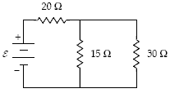
- What is the equivalent resistance?
0.575 kOHM
- Potential difference across each resistor
2.472 r1
1.406 r2
1.406 r3
- Current flowing through each resistor
6.80 r1
4.13 r2
2.62 r3
- Power dissipated by each resistor
16.8 r1
5.81 r2
3.68 r3

current through whole thing: 6.8 mA
e : 3.88V

Conclusions !
Write a report following the guidelines provided in the first procedure.

